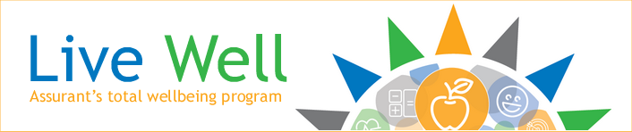

SHARE YOUR LIVE WELL STORY!

Do you have a success story you want to share around weight loss, healthy eating, fitness, resilience, community giving or any other wellbeing improvement success you've made as a result of participating in the Live Well program?
We'd love to hear from you! Please fill out this form and email to: LiveWell@assurant.com.
First Name: _________________________________ Last Name: _______________________________________
Phone number: ________________________________________
Email: ________________________________________________
Work Location: ________________________________________
Testimonial Statement:

May we contact you to talk more about this experience? ☐ Yes ☐ No

Authorization:
☐ I authorize Assurant to use this testimonial information in internal employee communication.
☐ I authorize Assurant to use this testimonial information in internal employee communication without my name.

